St Peter’s CE Middle School Curriculum Overview
Subject: Religious Education
Year 5 | Autumn 1 | Autumn 2 | Spring 1 | Spring 2 | Summer 1 | Summer 2
 | Topic:  The Bible Story   | Topic:  The Messiah  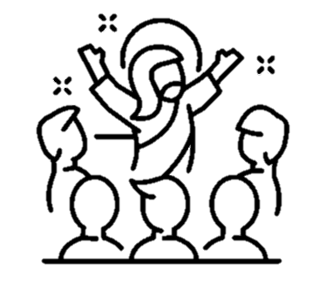 | Topic:  Sikhism  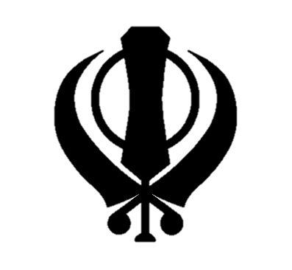 | Topic:  Easter  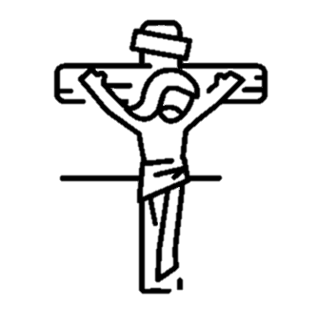 | Topic:  Worship  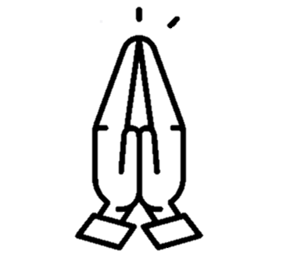 | Topic:  Places of Worship  
 | Concept:  -  The overview of the Bible  The fall  Noah and the Flood  What is sacrifice?  Who was Moses? | Concept:  Why was Jesus needed on earth?  Did people know he was coming?  What are the gospels?  The miracles of Jesus  Christmas | Concept:  What is a Sikh?  Who was Guru Nanak?  What do the 5 K’s represent?  What happens in a Gurdwara? | Concept:  What happened in Holy Week?  What is Maundy Thursday?  What happened on Good Friday and Easter Sunday? | Concept:  Having Worth  How is music, prayer, art, artefacts used in worship?  Who do I worship? | Concept:  Why do people need a place of worship? What are the main places of worship for the different religions?
 | Skills:  Comparing  Interviewing  Questioning  Weighing up ideas  Imagining | Skills:  Asking questions  Evaluating  Imagining  Explaining concepts  Interpreting Art  Religious literacy | Skills:  Comparing  Exploring significance  Empathising | Skills:  Questioning  Evaluating  Imagining  Analysing  Weighing up of ideas  Religious literacy | Skills:  Imagining  Questioning  Religious Literacy  Weighing up ideas  Empathising | Skills:  Discussion  Comparing  Weighing up ideas  Exploring  Interpreting art
 | Outcome:  A broad understanding of the underlying story in the Bible | Outcome:  An evaluated opinion on Jesus as a rescuer | Outcome:  An empathic understanding of the life and beliefs of a Sikh | Outcome:  An understanding of the Christian beliefs surrounding the story of Easter | Outcome:  An understanding and empathy for the concept of worship | Outcome:  A broad recognition of different places of worship

Year 6 | Autumn 1 | Autumn 2 | Spring 1 | Spring 2 | Summer 1 | Summer 2
 | Topic:  Moses  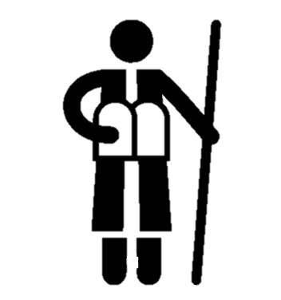 | Topic:  King Jesus  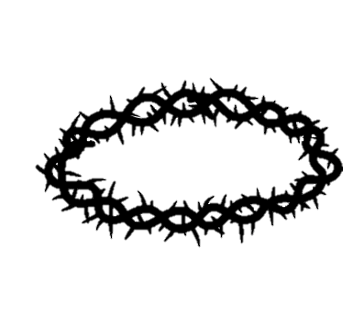 | Topic:  Hinduism  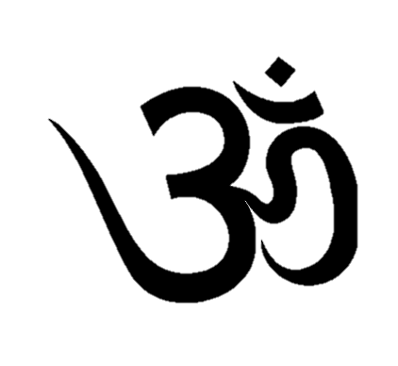 | Topic:  The Resurrection | Topic:  Pilgrimage   | Topic:  Creation Theories  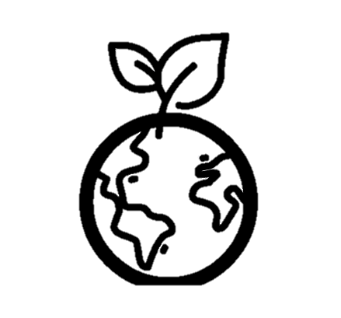
 | Concept:  -What are freedom and Justice?  -Why did Moses start following God?  -How did Moses bring freedom to the people of God?  -Why were there commandments and do we need them today?  -What does Moses’ story have to do with Jesus? | Concept:  -Why does the world need a rescuer?  -What is the kingdom of God?  -What kind of king was Jesus?  -How easy is it to bring heaven to earth?  -Who can be a kingdom maker? | Concept:  -Where are Hindus trying to go?  -How does reincarnation work?  -Is Karma a good or a bad thing?  -Does belief in Karma help Hindus lead better lives?  -What is Puja? | Concept:  -What evidence is there to suggest Jesus was resurrected?  -How does believing in the resurrection make a difference to how Christians live today?  -Was Jesus’ death and resurrection all part of God’s plan? | Concept:  -What do Christians believe about pilgrimage?  -Where do Hindus go on pilgrimage?  -Where do Jews go on pilgrimage?  -What is Hajj?  -What do Buddhists believe about pilgrimage? | Concept:  -What is the Judeo-Christian story of creation?  -Can I compare the creation stories of the Abrahamic religions?  -What is the Hindu creation story?  -What are the Sikh beliefs about creation?  -Why are there different types of creation stories?
 | Skills:  Comparing  Questioning  Analysing  Imagining  Empathising | Skills:  Asking questions  Comparing  Challenging  Evaluating  Weighing up ideas  Imagining | Skills:  Questioning  Comparing  Evaluating  Applying  Imagining  Empathising | Skills:  Questioning  Evaluating  Imagining  Analysing  Weighing up of ideas  Religious literacy | Skills:  Comparison  Evaluating  Empathising  Imagining | Skills:  Comparison  Sequencing  Evaluating  Analysing  Religious Literacy
 | Outcome:  A comprehensive understanding of the themes running through the story of Moses | Outcome:  An understanding of the kingdom of God on Earth | Outcome:  An empathic understanding of the life and beliefs of a Hindu | Outcome:  An understanding of a Christian’s beliefs in the resurrection | Outcome:  A knowledge and respect of those who go on spiritual journeys | Outcome:  An understanding of a wide range of creation theories

Year 7 | Topic:  Why are people good and bad?  (Fall) | Topic:  If God is trinity, what does that mean for Christians?  (God) | Topic:  How do Muslims practice their faith?  (Islam) | Topic:  Easter | Topic:  Creation and science – Conflicting or complementary?  (Creation, Fall) | Topic:  Life after Death
 | Concept:  -What makes people good and bad?  -What is God like in Genesis 1 & 2?  -Are humans made in the image of God?  -How should people be treated?  -How does God’s relationship with humans’ change?  -Is it all Eve’s fault?  -Why are people good and bad? | Concept:  -How do people describe God?  -What does the Apostles creed say about God?  -How could the trinity be like a timeline?  -What gifts does the Holy Spirit bring? | Concept:  -How did Islam begin?  -What are the five pillars of Islam?  -What is the holy book of Islam?  -Where do Muslims worship?  -What are the festivals of Islam?  -How do Muslims express their faith? | Concept:  -What is the difference between free will and determinism?  What is the evidence for the resurrection?  -What is sacrifice? | Concept:  -What is the purpose of Genesis 1  -What does Science say about creation?  -Do Genesis 1 and science contradict each other?  -Can Christians believe in God and science?  -Creation and Science: Conflicting or complementary? | Concept:  -What is the evidence for reincarnation?  -What do Christians teach about the afterlife?  -How do different religions bury their dead?
Year 7 | Topic:  Good and Evil  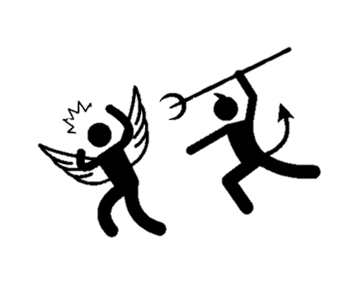 | Topic:  The Trinity  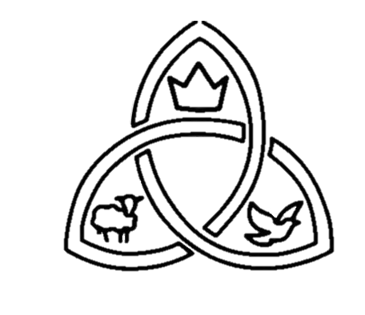 | Topic:  Islam  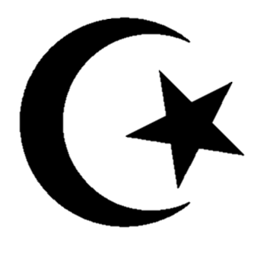 | Topic:  Sacrifice  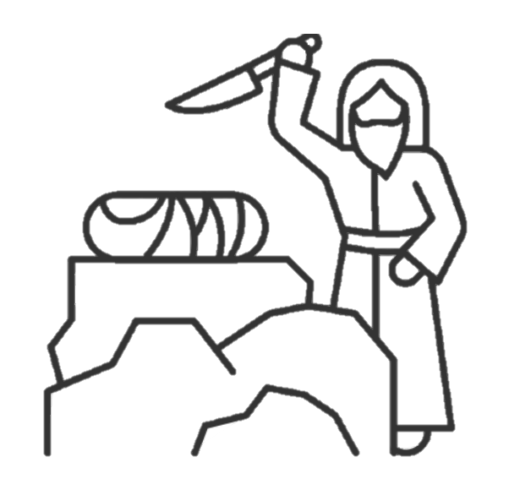 | Topic:  The Universe   | Topic:  Death  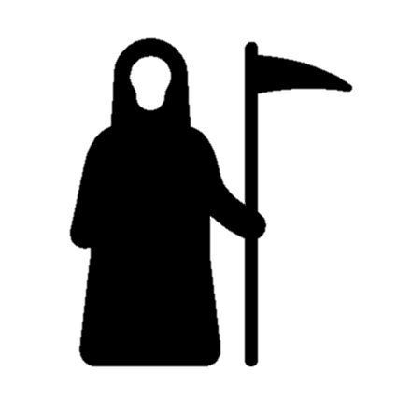
 | Concept:  -What makes people good and bad?  -What is God like in Genesis 1 & 2?  -Are humans made in the image of God?  -How does God’s relationship with humans’ change?  -Is it all Eve’s fault? | Concept:  -How do people describe God?  -What does the Apostles creed say about God?  -How could the trinity be like a timeline?  -What gifts does the Holy Spirit bring? | Concept:  -How did Islam begin?  -What are the five pillars of Islam?  -What is the holy book of Islam?  -Where do Muslims worship?  -What are the festivals of Islam?  -How do Muslims express their faith? | Concept:  What is a sacrifice?  What have I sacrificed in my own life?  Why do people need to sacrifice?  Who made the ultimate sacrifice according to Christianity? | Concept:  -What is the purpose of Genesis 1  -What does Science say about creation?  -Do Genesis 1 and science contradict each other?  -Can Christians believe in God and science?  -Creation and Science: Conflicting or complementary? | Concept:  -What is the evidence for reincarnation?  -What do Christians teach about the afterlife?  -How do different religions bury their dead?
 | Skills:  Asking questions  Interpreting different texts  Comparing  Analysing  Evaluating  Applying | Skills:  Interpreting art  Comparing  Questioning  Applying  Weighing up ideas  Imagining  Reflecting | Skills:  Questioning  Applying  Evaluating  Imagining  Empathising  Analysing | Skills:  Questioning  Analysing  Religious Literacy  Reflecting  Applying | Skills:  Applying  Analysing  Evaluating  Empathising  Reflecting | Skills:  Comparing  Analysing  Religious literacy  Weighing up ideas  Evaluating  Interpreting text
 | Outcome:  An understanding of the Christian beliefs of good and evil | Outcome:  An understanding of what the Trinity means to Christians | Outcome:  An empathic understanding of the life and beliefs of a Muslim | Outcome:  A knowledge of the concept of sacrifice in relation to religions and one’s own life | Outcome:  A wider understanding of the different beliefs about the universe | Outcome:  An understanding and respect for death rites and rituals in other religions

 | Autumn 1 | Autumn 2 | Spring 1 | Spring 2 | Summer 1 | Summer 2
Year 8 | Topic:  Back to Basics  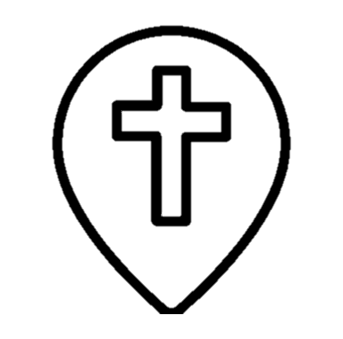 | Topic:  The Big Questions  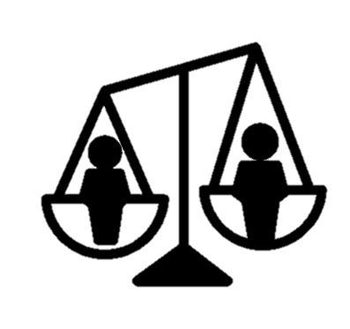 | Topic:  Moral Dilemmas   | Topic:  Son of God  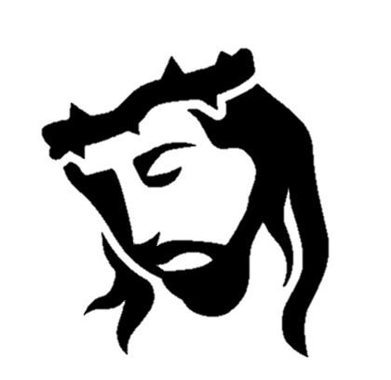 | Topic:  Buddhism  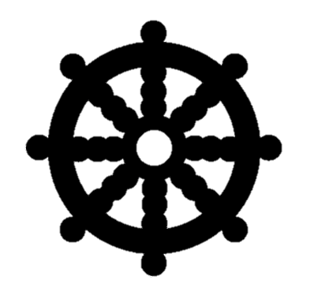 | Topic:  Christians in conflict  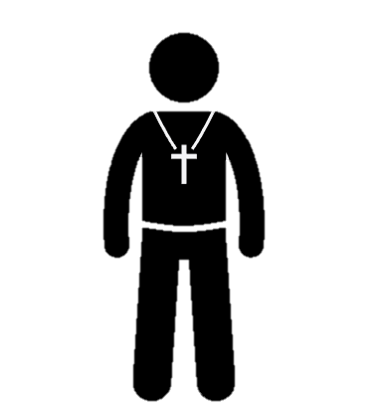
 | Concept:  What is my own personal faith?  What are the main beliefs of the six big world religions?  Who do they say Jesus is?  Can I compare two religions? | Concept:  What do I believe about prejudice and discrimination?  What do I believe about gender equality and racism?  How does money and religion interlink? What do different religions believe about all of these? | Concept:  What are the rights and wrongs about capital punishment, euthanasia, abortion, and other moral dilemmas?  What do different religions believe about these? | Concept:  Who really was this Son of God?  What is the truth about his miracles?  Was Jesus’ trial ethical? | Concept:  The origin of Buddhism  The noble truths and the eightfold path  Life as a Buddhist  Karma, Rebirth and Nirvana  The Vihara | Concept:  Why do Christians believe different things?  The divided church  Northern Ireland  Current Conflicts
 | Skills:  Looking closely  Evaluating  Imagining  Comparing  Reflecting | Skills:  Exploring through music  Weighing up ideas  Arguing  Empathising  Asking Questions | Skills:  Empathising  Applying  Asking questions  Challenging  Reflecting | Skills:  Questioning  Asking questions  Imagining  Evaluating  Empathising | Skills:  Challenging  Questioning  Applying  Religious Literacy  Empathising  Reflecting | Skills:  Weighing up ideas  Comparing  Asking questions  Challenging  Evaluating
 | Outcome:  A mature reasoning as to their own beliefs and an empathy for the beliefs of others | Outcome:  A mature reasoned understanding of how different people view these big questions differently | Outcome:  A mature reasoned understanding of how different people view these moral dilemmas differently | Outcome:  A fact-based understanding of the man Jesus Christ, the reality of his death | Outcome:  An empathic understanding of the life and beliefs of a Buddhist | Outcome:  A historical understanding of the divided Church

